**AWS BASICS**

**CONTENT**

* Public,private and hybrid cloud and top cloud
* Service offerings(iaas,paas,saas)
* Regions and availability zones
* Aws billing concept

**What is cloud?**

Cloud computing is the on-demand delivery of IT resources over the Internet with pay-as-you-go pricing. Instead of buying, owning, and maintaining physical data centers and servers, you can access technology services, such as computing power, storage, and databases, on an as-needed basis from a cloud provider like Amazon Web Services (AWS).

**Who is using cloud computing?**

Organizations of every type, size, and industry are using the cloud for a wide variety of use cases, such as data backup, disaster recovery, email, virtual desktops, software development and testing, big data analytics, and customer-facing web applications. For example, healthcare companies are using the cloud to develop more personalized treatments for patients. Financial services companies are using the cloud to power real-time fraud detection and prevention. And video game makers are using the cloud to deliver online games to millions of players around the world.

**Some types of clouds**

**1.public cloud:**it is kind of cloud which is accessible publically to all the people in the world just as aws,gcp and azure.

**2.Private cloud:**

This is a kind of cloud which si privately owned by a company and its resources are not accessible to the outside world.

**3.hybrid cloud:**

As the names says it is a kind of cloud which act as both a public an d aprivate cloud.As some things which the organization needs to be private can be kept over a private network but some things which can be accessed by the world are made public.

**Benefits of cloud computing**

**1.Agility**

The cloud gives you easy access to a broad range of technologies so that you can innovate faster and build nearly anything that you can imagine. You can quickly spin up resources as you need them–from infrastructure services, such as compute, storage, and databases, to Internet of Things, machine learning, data lakes and analytics, and much more.

**2.Elasticity**

With cloud computing, you don’t have to over-provision resources up front to handle peak levels of business activity in the future. Instead, you provision the amount of resources that you actually need. You can scale these resources up or down to instantly grow and shrink capacity as your business needs change.

**3.Cost savings**

The cloud allows you to trade fixed expenses (such as data centers and physical servers) for variable expenses, and only pay for IT as you consume it. Plus, the variable expenses are much lower than what you would pay to do it yourself because of the economies of scale.

**4.Deploy globally in minutes**

With the cloud, you can expand to new geographic regions and deploy globally in minutes. For example, AWS has infrastructure all over the world, so you can deploy your application in multiple physical locations with just a few clicks. Putting applications in closer proximity to end users reduces latency and improves their experience.

**Types of cloud computing**

The three main types of cloud computing include Infrastructure as a Service, Platform as a Service, and Software as a Service. Each type of cloud computing provides different levels of control, flexibility, and management so that you can select the right set of services for your needs.

**1.Infrastructure as a Service (IaaS)**

IaaS contains the basic building blocks for cloud IT. It typically provides access to networking features, computers (virtual or on dedicated hardware), and data storage space. IaaS gives you the highest level of flexibility and management control over your IT resources. It is most similar to the existing IT resources with which many IT departments and developers are familiar.

**2.Platform as a Service (PaaS)**

PaaS removes the need for you to manage underlying infrastructure (usually hardware and operating systems), and allows you to focus on the deployment and management of your applications. This helps you be more efficient as you don’t need to worry about resource procurement, capacity planning, software maintenance, patching, or any of the other undifferentiated heavy lifting involved in running your application.

**3.Software as a Service (SaaS)**

SaaS provides you with a complete product that is run and managed by the service provider. In most cases, people referring to SaaS are referring to end-user applications (such as web-based email). With a SaaS offering, you don’t have to think about how the service is maintained or how the underlying infrastructure is managed. You only need to think about how you will use that particular software.

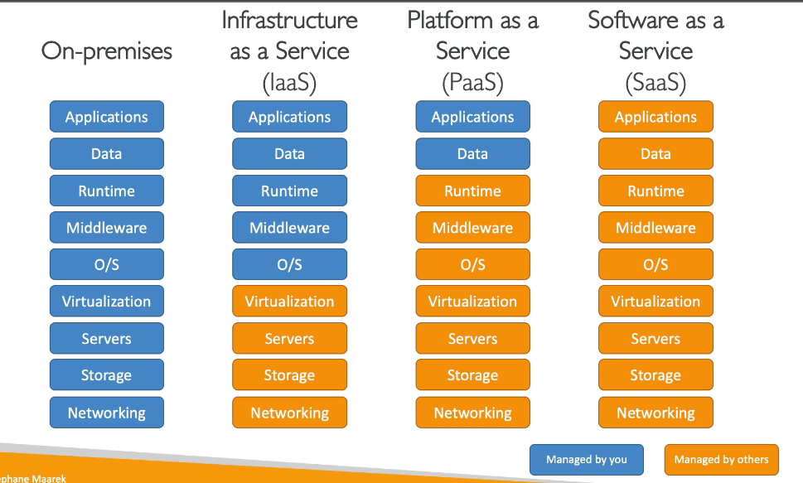

**PRICING IN THE CLOUD**

Aws has 3 pricing fundamenetals,following the pay as you go pricing model:

1.**compute:**pay for the computer time

**2.Storage:**pay for the data stored in the cloud

**3.data transfer out of the cloud:**pay for the datta transfer in is free but going out to some region takes some cost.

**AWS GLOBAL INFRASTRUCTURE**

**1.regions:**

A region is a cluster of data centers and aws has regions all across the globe and they can be named as eu-east1a..Most aws services are region scoped.

**Availability zones**

**3.data centers**

**4.edge locations/points of presence**

**HOW TO CHOOSE WHERE TO LAUNCH AN AWS REGION**

**1.COMPLIANCE:**we need to compliance with the data governance and legal requirements .There are rules sometimes that some data cannot move out of a country.

**2.PROXIMITY/LATENCY:**we need to take care of the latency rate so that the users can reach out to the data in as least possible time so we choose the region accordingly.

**3.AVAILABLE SERVICES:**some services are not available in some regions

**4.PRICING:**also it depends upon pricing how much we want to pay for that service so we choose according to our budget.

**AWS AVAILABILITY ZONES**

Each region in aws has some availability zones.It ususllay have three,min is 2 and max is 6.

Each az is one or more data center with redundant power,networking and connectivity.

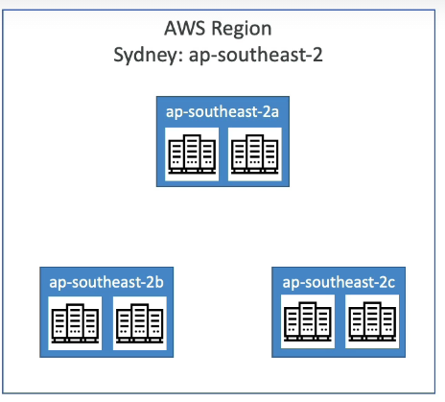

All the az are connected with high bandwidth and ultra low latency networking

**POINTS OF PRESENCE/EDGE LOCATIONS**

Amazon has 216 points of presence in 84 citites across 42 countries.

These are kept so that the content is delivered to end users with lower latency.

**GLOBAL SERVICES IN AWS**

Iam,route53,cloudfront,waf(web application firewall,)

**Region scoped aws services**

Amazon ec2(IAAS)

Elastic beanstalk(paas)

Lambda(function as a service)

Recognition(software as a service)